Smart Electricity Meter Monitoring and Prediction using iSocket
Aim:
Aim of the project is to build a smart home automation system to control home appliances, monitor the power consumed by the appliances and predict the power consumption using machine learning algorithm.
Synopsis:
In order to implement the concepts of smart residential automation, this project develop a prototype for power consumption monitoring in smart homes. In this device we embed a voltage and current sensor for individual sockets, then we can measure the power consumed over a time. Day wise the power consumption data will be stored in the cloud data base.
Using Machine learning algorithm we can predict the consumption of power in future days. Prediction of power consumption helps the consumer to calculate the Electricity bills, individual usage of blocks and etc.
Here, NodeMCU used as master microcontroller to monitor the power usage of devices and control of devices. This controller can directly connected network and cloud database and receive the control signals from the android mobile from user.
Customized android mobile application is designed to monitor the power usage and control the home appliances from anywhere through internet.
Existing System:
Existing system monitors the power consumption of individual devices and plot to visualize the data to user.
Proposed System:
Proposed system can monitor power usage as well as control the devices from user-end. Also Random forest machine learning algorithm is used to predict the power usage in future day.
Block Diagram:
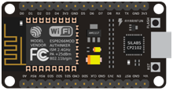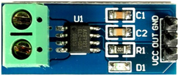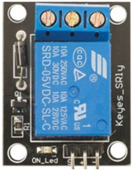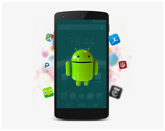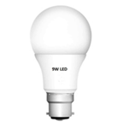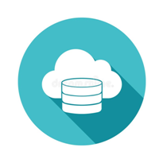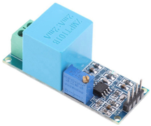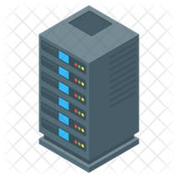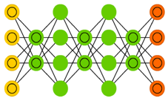
ML Model
Python server
Cloud database
Android Application
NodeMCU Controller
Voltage Sensor
Current Sensor
Relay Boards
Load Devices

Requirements:
Hardware requirements:
- NodeMCU
- Voltage Sensor
- Current sensor
- Relay Boards
- Load Devices (Bulbs and Fan)
- Android Mobile
- Laptop with 8GB RAM and i3/i5 Processor or equ.
Software requirements:
- Arduino IDE
- Android Studio
- Python 3.7
- Anaconda

